Aamir Patel

IS 215

6/1/2021

Module 9

ERD Diagram

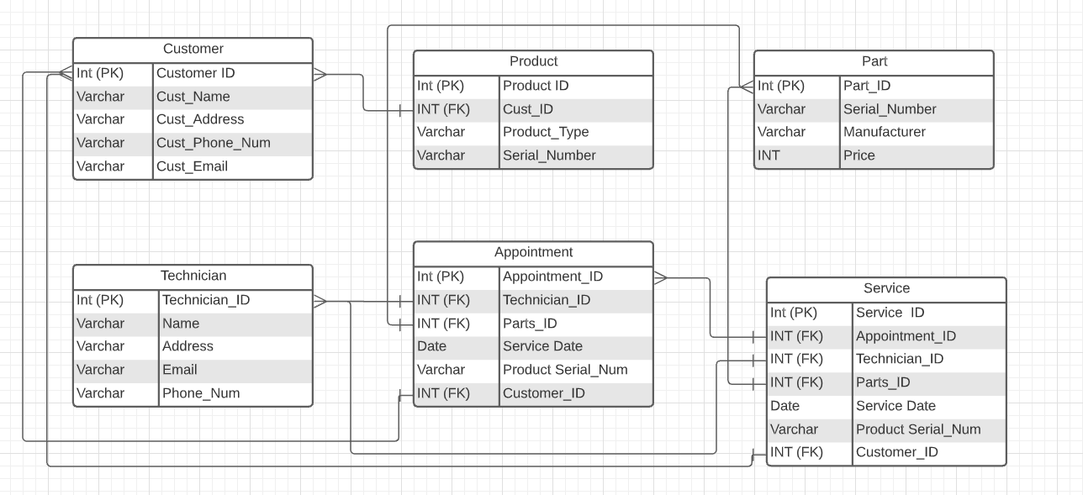

Entities/Relationships:

* **Customer:** A customer can have multiple items related to it so it’s a 1: M.
* **Product: -** A product can be owned by one customer, but one customer can own multiple products, so it’s a M:1.
* **Part:**  A Part# can be used for multiple appointments, so it’s a 1: M.
* **Technician:** A Technician can perform multiple services, so it’s a 1: M.
* **Appointment:** To set an appointment a lot of information is required, so it’s a M:1.
* **Service: -** Service is performed by one technician, but to do a service a lot of information is required, such as appointment_ID, Technician_ID, Parts_ID, Customer_ID. So, it’s a M: N.